2013 Service Learning Project

Students in Oklahoma Flora, Biology 3213, completed a service learning project on the Northeastern State University Broken Arrow Campus (NSU-BA). This project required the students to analyze campus tree census data collected in the fall of 2012. The 2012 census included only the portions of campus that are managed (the mowed portions of campus) The students verified the previous collected data and calculated the following parameter:

1. Tree Characteristics including:

a. Number of trees on campus

b. Number of species on campus

c. Average dbh (cm)

d. Average condition of each tree based on a 1-5 rating system

2. Most common family, genus and species of trees on campus.

3. Estimated Compensatory Value using I-Tree values.

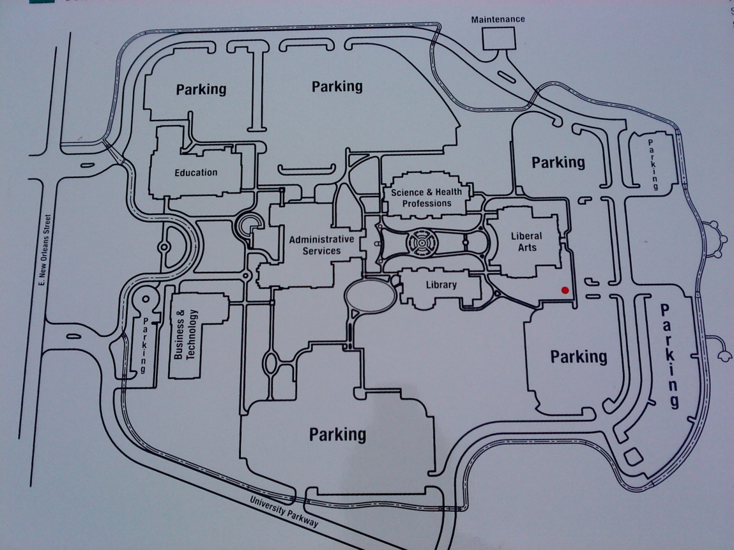

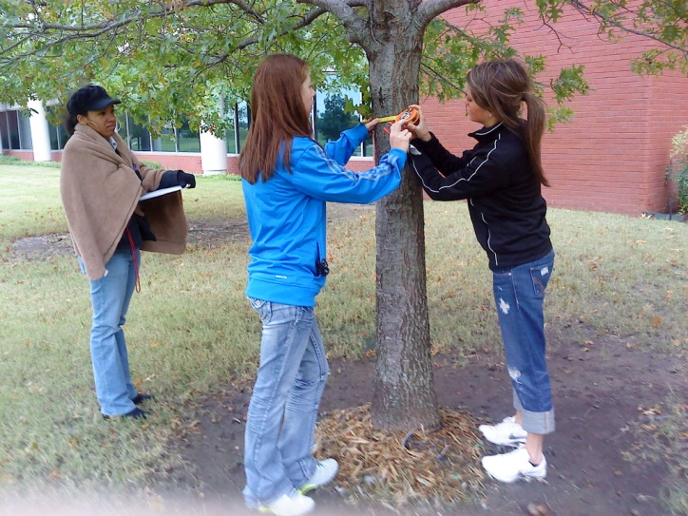

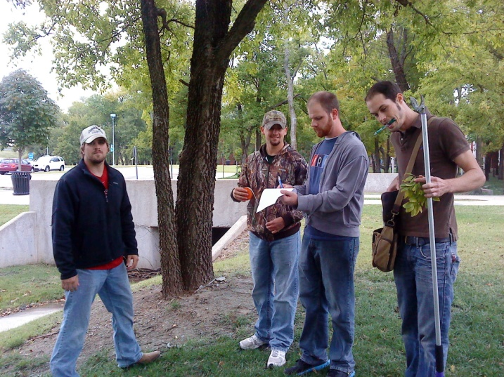

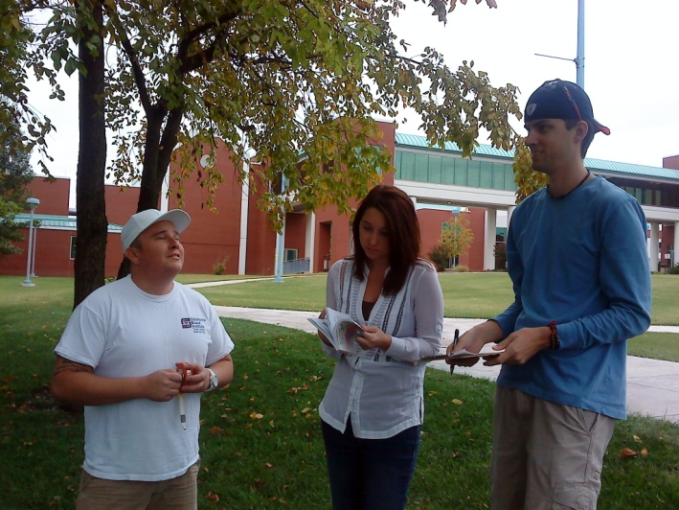

# Figure 1: Size Distribution of Trees on NSU-BA Campus

# Figure 2: Condition Ratings of NSU-BA Campus Trees

# Table 1: Summary of Trees on the Managed Areas of NSU-BA Campus

|  |  |
| --- | --- |
| Number of trees on campus | 339 |
| Number of Species on Campus | 16 |
| Average dbh (cm) | 25.1 |

# Table 2: Family, Genus and Species Composition of NSU-BA Campus Trees

|  |  |  |  |  |  |  |  |  |
| --- | --- | --- | --- | --- | --- | --- | --- | --- |
| Family | Number of trees | Percent of Population | Genus | Number of Trees | Percent of Population | Species | Number of trees | Percent of Population |
| Ulmaceae | 100 | 29.5% | Celtis | 85 | 25.1% | Celtis laevigata | 69 | 20.4% |
| Fagaceae | 75 | 22.1% | Quercus | 75 | 22.1% | Pinus taeda | 44 | 13.0% |
| Oleaceae | 58 | 17.1% | Fraxinus | 58 | 17.1% | Acer rubrum | 43 | 12.7% |
| Pinaceae | 44 | 13.0% | Pinus | 44 | 13.0% | Ulmus americana | 41 | 12.1% |
| Aceraceae | 43 | 12.7% | Acer | 43 | 12.7% | Quercus rubra | 23 | 6.8% |
| Caesalapinaceae | 9 | 2.7% | Ulmus | 15 | 4.4% | Celtis occidentalis | 21 | 6.2% |
| Platanaceae | 5 | 1.5% | Cercis | 9 | 2.7% | Quercus nigra | 18 | 5.3% |
| Ebenaceae | 3 | 0.9% | Platanus | 5 | 1.5% | Cercis canadensis | 9 | 2.7% |
| Moraceae | 2 | 0.6% | Diospryos | 3 | 0.9% | Fraxinus pennsylvanica | 9 | 2.7% |
|  |  |  | Morus | 2 | 0.6% | Quercus palustris | 4 | 1.2% |
|  |  |  |  |  |  | Diospryos virginiana | 3 | 0.9% |
|  |  |  |  |  |  | Quercus shumardii | 2 | 0.6% |
|  |  |  |  |  |  | Quercus velutina | 2 | 0.6% |
|  |  |  |  |  |  | Quecus stellata | 1 | 0.3% |

# Figure 3: Percent Species Composition for the Most Common Species on the NSU-BA Campus