OAPH/PAT ParkingPermit
Valid: 5 p.m., March 6, to 3 p.m., March 7
Print this page and display it on your dashboard during the OAPH/PAT Conference.
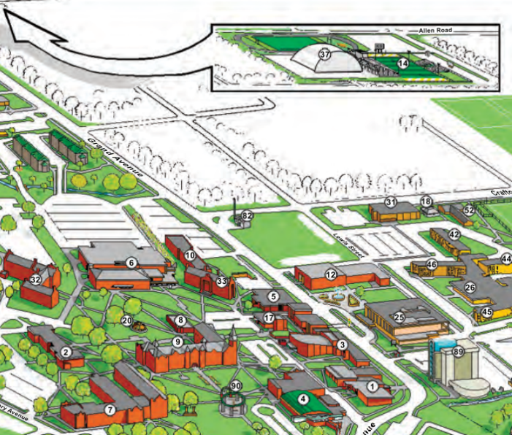
Thirty-two spaces have been reserved for conferees between the University Center (25) and the Webb Building (89). Parking also should be available across the street in the CASE Building (5) parking lot. If that lot is filled, parking is always available north of Doc Wadley Stadium (14—about half a mile north of the UC on Grand Avenue), and a shuttle service will operate between it and the University Center every few minutes. Conferees will be allowed to park in any spaces in commuter lots if the parking permit is displayed on the vehicle dashboard.

