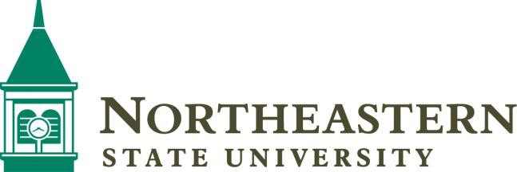

Gregg Wadley College of Science & Health Professions

2026-2027 Nutritional Sciences – Dietetics*
First Year
Fall Semester | Spring Semester
ENGL 1113 English Composition 1 | ENGL 1213 English Composition II
BIOL 1013/1011 Introductory Biology I and Lab | POLS 1113 American Federal Government
MATH 1513 College Algebra | NUTR 1653 Basic Nutrition
Humanities-Fine Arts App. (3 hrs) See list in NSU catalog | NUTR 3653 Food and Culture
UNIV 1003 University Strategies | CHEM 1123/1131 Chemistry I Lecture plus Lab (4 hrs)
Total Hours 16 | Total Hours 16

Second Year
Fall Semester | Spring Semester
Communications (3 hrs) See list in NSU catalog | NUTR 3954 Food System Management
BIOL 3314 Human Physiology | Humanities-Culture & Ideas (3 hrs) See list in NSU catalog
CHEM 1223/1231 Chemistry II Lecture and Lab | CHEM 3123/3131 Organic 1 Chemistry Lecture and Lab
NUTR 3104 The Science of Food | BIOL 3224 Microbiology
NUTR 3201 Food Safety | Computer Proficiency or CS/IS 1003 (online)
Total Hours 16 | Total Hours 18

Third Year
Fall Semester | Spring Semester
CHEM 4214 Biochemistry | HIST 1483 or 1493 Am Hist. (1492-1876 or since 1876)
PSYC/SOC 1113 Intro to Psychology/Sociology | NUTR 3763 Medical Nutrition Therapy I
NUTR 3583 Nutritional Assessment and Counseling | NUTR 4243 Life Cycle Nutrition
NUTR 3111 Intro to Nutritional Sciences | NUTR 4352 Advanced Nutrition
NUTR 3563 Fund of Med Nutrition Therapy | NUTR 4283 Community Nutrition
Total Hours 14 | Total Hours 14

Fourth Year
Fall Semester | Spring Semester
NUTR 4263 Geriatric Nutrition | Statistics Class (3 hrs) See List in NSU Catalog (online)
NUTR 4592 Health Careers Professionalism
NUTR 4583 Medical Nutrition Therapy II | Free Electives (12 hrs, online)
NUTR 4801 Summative Seminar in NS
Upper Division Free Elective (6 hrs, online)
Total Hours 15 | Total Hours 15
Total Degree Plan Hours 124

For further information, contact Dr. Katy Fuller, Program Director, 918-444-2942, fuller13@nsuok.edu
*This course sequence is designed to help students stay on track toward degree completion. Although some courses have prerequisite requirements, course sequencing may vary based on transfer credit, course availability, academic standing, and individual student needs. Students are encouraged to work closely with the Program Director to develop an individualized plan of study.

