GPS/Geocaching Lesson Plan

|  |  |  |  |  |  |
| --- | --- | --- | --- | --- | --- |
| Grade Level: | **6th Grade** | Subject: | General Music | Prepared By: | **Jennifer Prince** |

|  |  |
| --- | --- |
| Overview & Purpose The purpose of this lesson is to identify and review rhythm including types of notes/rest and the values they each hold. | Education Standards Addressed Standard 1-1 (Rhythm)  Standard 1-2 (Language of music, note values, time signatures)  Standard 3-8 (Music Expression through clapping and counting) |

|  |  |  |
| --- | --- | --- |
|  |  |  |
| Objectives (Specify skills/information that will be learned.) | Students will be able to identify each type of note and rest as well as identify the proper value each note/rest receives. Students will also be able to create a four bar rhythmic line using the notes and rest discussed in this activity as well as a four/four time signature. | Materials Needed  * Small containers with pictures of musical symbols inside * GPS unit * Worksheet that accompanies lesson |
| Information (Give and/or demonstrate necessary information) | This is a total of a two day project. One day to find the cashes and the next to complete the worksheet and share with the class each groups rhythmic line. |
| Verification (Steps to check for student understanding) | The verification for this lesson will be assessed based on the completion of the student’s worksheet and six bar rhythmic pattern. | Other Resources (e.g. Web, books, etc.) |
| Activity (Describe the independent activity to reinforce this lesson) | Students will be given the GPS coordinates. Using the GPS units students will work in pairs to adventure off and find the cashes. Within each cash will be a piece of paper with a musical symbol. Students will identify the musical symbol by name as well as draw a picture next to the coordinates. Later they will use the information found to complete a worksheet within class. |
| Summary | The students really enjoyed working on this assignment. They were very creative on putting together the rhythmic line part of the worksheet. Trying to find 8 caches was pushing it a little bit for our allotted time period but overall I thought the project was a huge success. It allowed them to review musical terminology while using technology and combining it with social studies and math. This was a very cross curricular project. The project took a total of two days. Day one was finding the caches and completing the first worksheet with the way points the second day was the completion of the worksheet in the classroom. | Additional Notes |

GEOCACHING Project  
Music and GEOCACHING a Cross Curricular Assignment

Photo of students out in the field, this combined music/social studies/technology

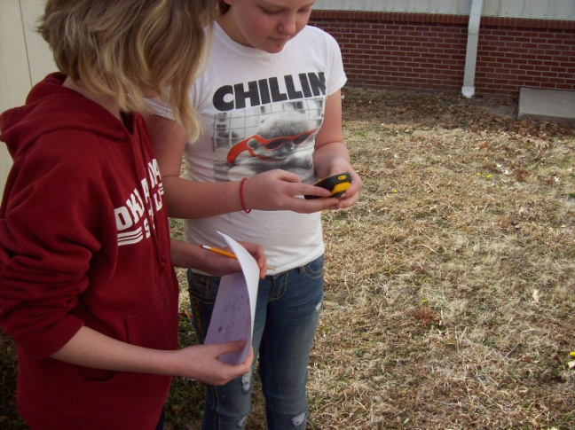 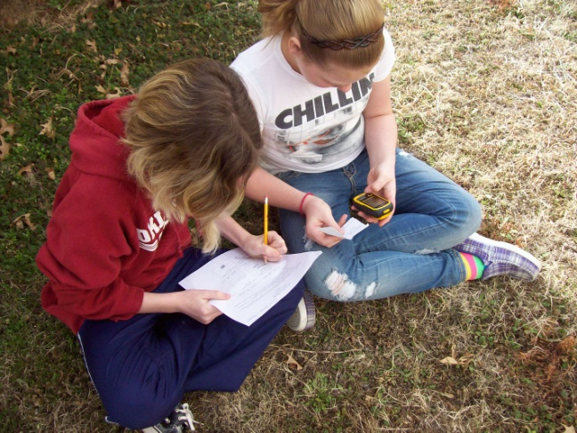

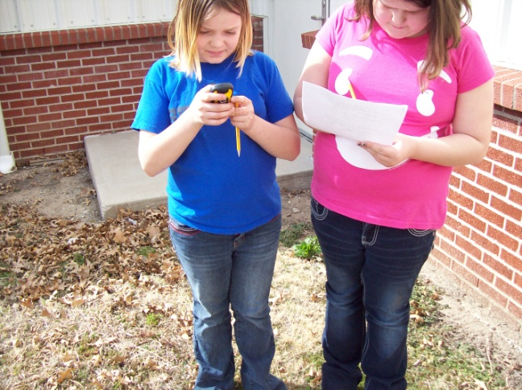 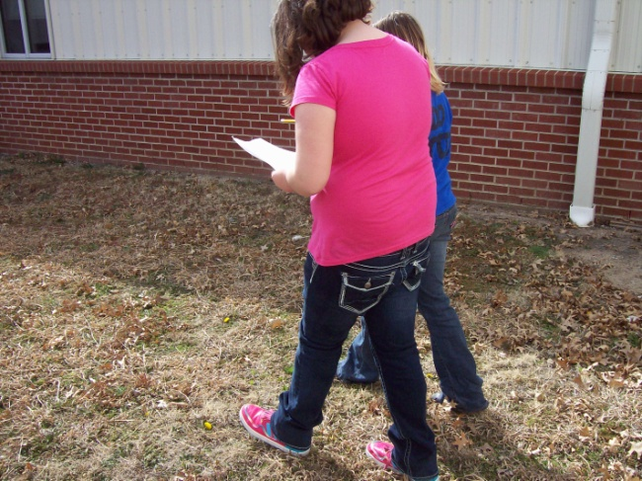

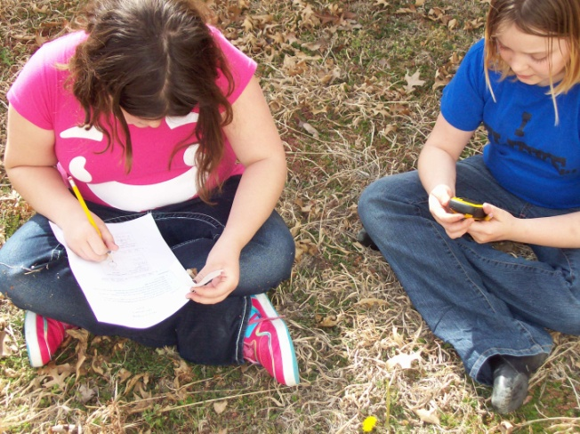 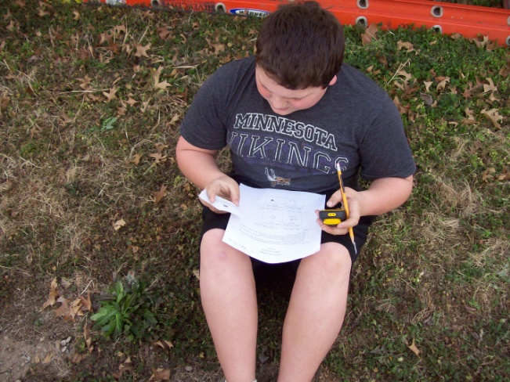

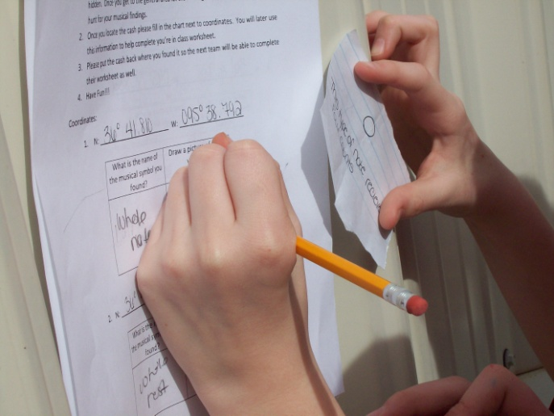 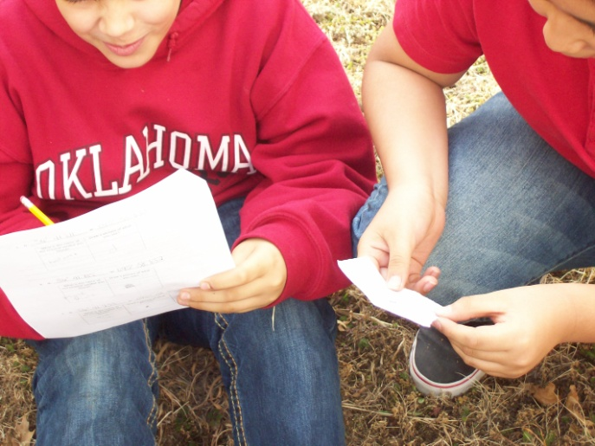

Here are some pictures of students working on the 2nd part of the project in the classroom. This combines elements of music, math and again social studies.

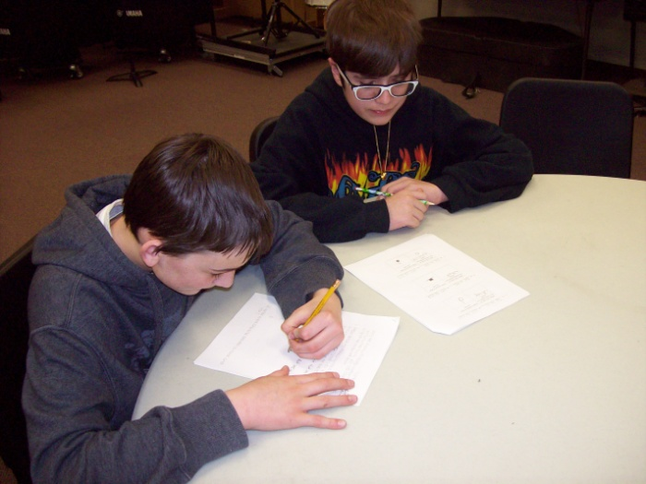 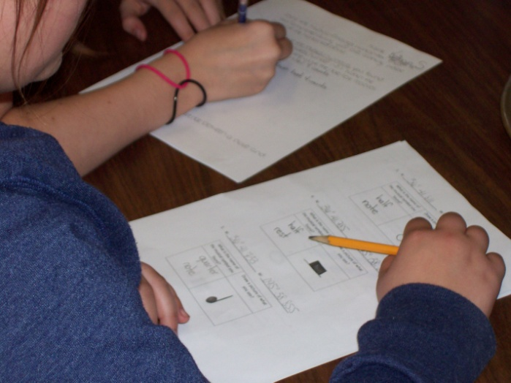

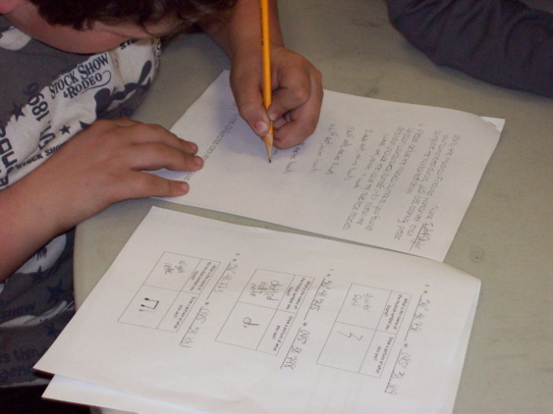 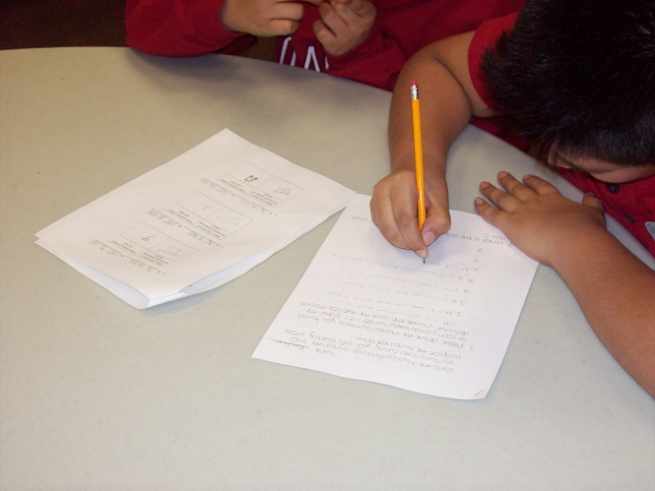

The following are pictures of the final project. The student used their field worksheets to complete a second worksheet in class that had three parts. 1 Identify by definition, 2 Math-O-Music (adding and subtracting musical values) and 3 Create a rhythmic line based on the notes and rest we used in this lesson.

